# Virtual Voice Assistant

Submitted in partial fulfillment of the requirements of the Degree

**BACHELOR OF ENGINEERING** IN **INFORMATION TECHNOLOGY**

By

**Vishnu Yelde 49**

**Prachiti Yadav 46**

**Aditya Sharma 37**

Supervisor

**Prof. Prajkta Khaire**





**Department of Information Technology**

Shivajirao S. Jondhale College of Engineering.

Dombivli (E)

(Affiliated to University of Mumbai)

(AY 2022-23)

# CERTIFICATE

This is to certify that the Mini Project entitled **“Virtual Voice Assistant”** is a bonafide work of Vishnu Yelde 49, Prachiti Yadav 46, Aditya Sharma 37, submitted to the University of Mumbai in partial fulfillment of the requirement for the award of the degree of **“Bachelor of Engineering”** in **“Information Technology”.**

### (Prof. Prajkta Khaire)

Supervisor

### (Prof. Savita Sangam) (Prof. Dr. P.R. Rodge)

Head of Department Principal

# Mini Project Approval

This Mini Project entitled “Virtual Voice Assistant**”** by Vishnu Yelde 49, Prachiti Yadav 46, Aditya Sharma 37 is approved for the degree of **Bachelor of Engineering** in **Information Technology.**

## Examiners

**1………………………………………**

(Internal Examiner Name &Sign)

### 2…………………………………………

(External Examiner name &Sign)

Date: Place:

# Contents

### Abstract ii

### Acknowledgments iii

### List of Abbreviations iv

### List of Figures v

### List of Tables vi

### List of Symbols vii

### Introduction 1

* 1. Introduction
  2. Motivation
  3. Problem Statement &Objectives
  4. Organization of the Report

### Literature Survey 11

* 1. Survey of Existing System
  2. Limitation Existing system or research gap
  3. Mini Project Contribution

### Proposed System (e.g. New Approach of Data Summarization ) 18

* 1. Introduction
  2. Architecture/ Framework
  3. Algorithm and Process Design
  4. Details of Hardware &Software
  5. Experiment and Results
  6. Conclusion and Future work.

### References 32

# ABSTRACT

The project aims to develop a personal-assistant for Window systems. Jarvis draws its inspiration from virtual assistants like Cortana for Windows, and Siri for iOS.​ It has been designed to provide a **user-friendly**​ **interface** for carrying out a variety of tasks by employing certain ​**well-defined commands**​. ​Users can interact with the assistant either through ​**voice commands** or using keyboard input.

As a personal assistant, Jarvis assists the end-user with day-to-day​ activities like general human conversation, searching queries in google, bing or yahoo, searching for videos, retrieving images, live weather conditions, word meanings, searching for medicine details, health recommendations based on symptoms and reminding the user about the scheduled events and tasks. The user statements/commands are analyzed with the help of ​**machine learning** to give an optimal solution.

# ACKNOWLEDGEMENT

We had a great experience working on this project and we got to learn a plethora of new skills through this project. However, it would not have been possible without the kind support and help of many individuals. We would like to extend our sincere thanks to all of them. We are highly indebted to the teachers and especially ​**Prof. Prajkta Khaire** for​ their guidance and constant supervision as well as providing necessary information regarding the project and also for their support in completing the project.

1. **INTRODUCTION**

Voice assistant is used to run machine like laptop or PC’s on your own command. Virtual assistant is used to perform a typical task like showing datetime, managing emails, open apps, etc. on your command. Now a days virtual assistant is very useful to human. It makes human life easier like operate PC’s or laptop on only voice command. Virtual assistant is a less time consuming. By using virtual assistant we saves our time and contribute in other works. Virtual assistants are typically cloud-based program that requires internet connected devices. Virtual assistant is the flexibility to contract for just the services they need. For creating virtual assistant for your computer go from basics python. Virtual assistants are task-oriented. Virtual assistants ability to understand and perform requests. Virtual assistants is a software that understands verbal and written commands and completes task assigned by clients. Virtual assistants are able to interpret human speech and respond via synthesized voices. There are several voice assistants in market like Siri for apple TV remote, Google Assistant for pixel XL smartphones, Alexa as a smart speaker which is developed by using Raspberry Pi, Microsoft Cortona for windows 10. As like this all virtual assistants we also created a virtual assistant for windows. We use Artificial Intelligence technology for this project. Also use python as a programming language, because python offers a good major libraries. For this software use microphone as input device to receive voice requests from user and speaker as output device to give the output voice. This process is the combination of several different technologies like voice recognition, voice analysis and language processing. Virtual assistant use Natural Processing language to match user text or voice input to executable commands. When a user give a command to personal virtual assistant to perform a task, the natural language is converted the audio signals into digital signals.

1. **LITERATURE REVIEW**

In the existing system of virtual assistant there are several virtual assistants in market by using Artificial Intelligence technology. Many companies have used the dialogue systems technology to establish various kinds of Virtual Personal Assistants (VPAs) based on their applications and areas, such as Microsoft’s Cortona for Windows and Espeak for Linux, Siri for Apple, Google Assistants For Android.[1] The first digital virtual assistant installed on a smartphone of apple was Siri, It was introduced as a feature of the iphone in 2011. Aim of that virtual assistant was to add in tasks such as sending a text message, making phone calls, checking the weather or setting up an alarm. Over time, it has developed to provide restaurant locations , search the internet, and provide driving directions. In 2014 Cortona virtual assistants was developed by Microsoft. Cortona uses Bing search engine for performing tasks like answering questions for the users, setting remainder, etc. In 2016 Google Assistant was developed by google. It is primarily available for mobiles and smart home devices. Google Assistants via chat on google messaging app and via voice on google smart home speaker.Cortona was developed by Microsoft as personal virtual assistant for windows, iOS, android, etc. In windows operating system Cortona works only for windows 10. It was released for windows 10 in 2015. In windows 10 Cortona is in Icon form on taskbar next to the search bar for use the cortona application we try to setup for activate the Cortona in our laptop or PC’s. It is easy to search but it takes more time to setup. It is very time consuming. It works in windows only for windows 10. It is not helpful for other windows version or explorer like windows 7, 8, etc. Therefore for other versions of windows we try to make the personal virtual assistant which is able to access on any windows explorer such as windows 7,8,10. In this project we use Python as a programming language and pycharm as a platform on which we execute our code for virtual assistant. We create the personal virtual assistants web application in the form of .exe file which is easy to get in any laptop or PC’s and use it, for showing datetimes, managing emails, playing music, videos, open apps, etc. In our virtual assistant user can able to train or update it by their own needs to do some tasks.

1. **PROPOSED SYSTEM**

**INTRODUCTION**

The proposed system of voice assistant will solve some issues of existing system as well introduce new features for better quality and usage. So, let’s have a brief of the new updated version of the voice assistant.

**FLOWCHART**

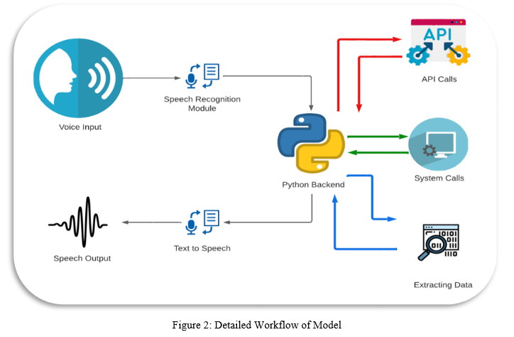

**RESULTS AND DISCUSSION**

Virtual assistant is a less time consuming. Virtual assistant is a software that understands verbal or written commands and complete task assigned by client. Virtual assistant use natural language processing (NLP) to match user voice or text input with executable commands. With the help of virtual assistant you able to run your machine like laptop or PC’s on your own command. It is the fast process, therefore it saves time. Virtual assistant is working for you at set times, so always available to you and able to adapt to changing needs quickly. Virtual assistant will be available to you and, should their workload enable, help others too, such as family and colleagues.

**RESULTS**

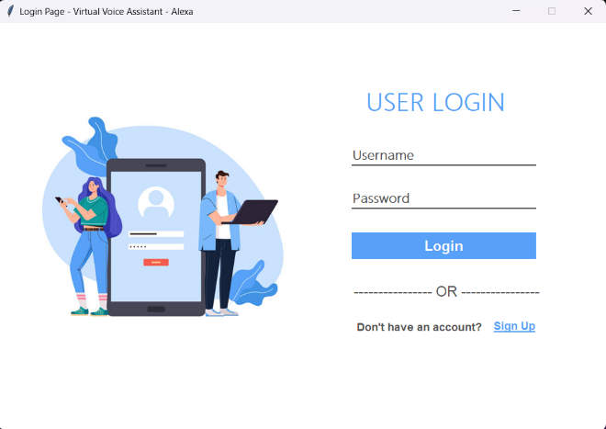 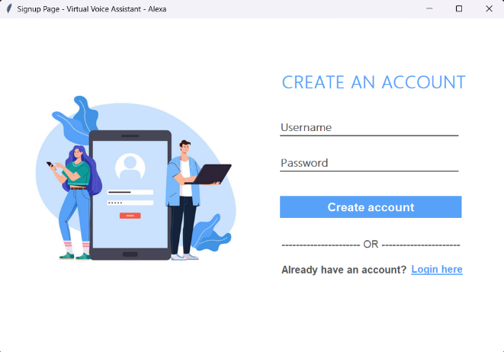

Login Page Signup Page

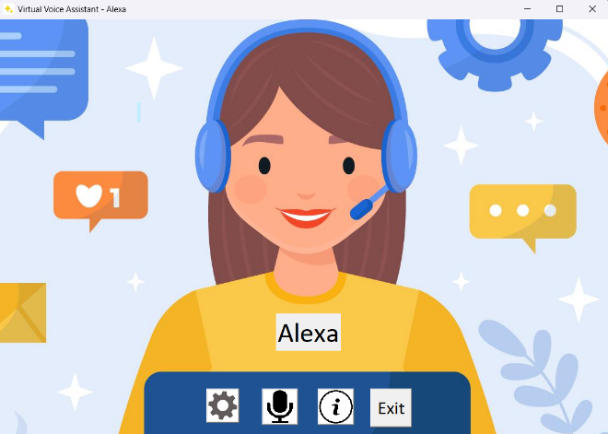

Main Screen

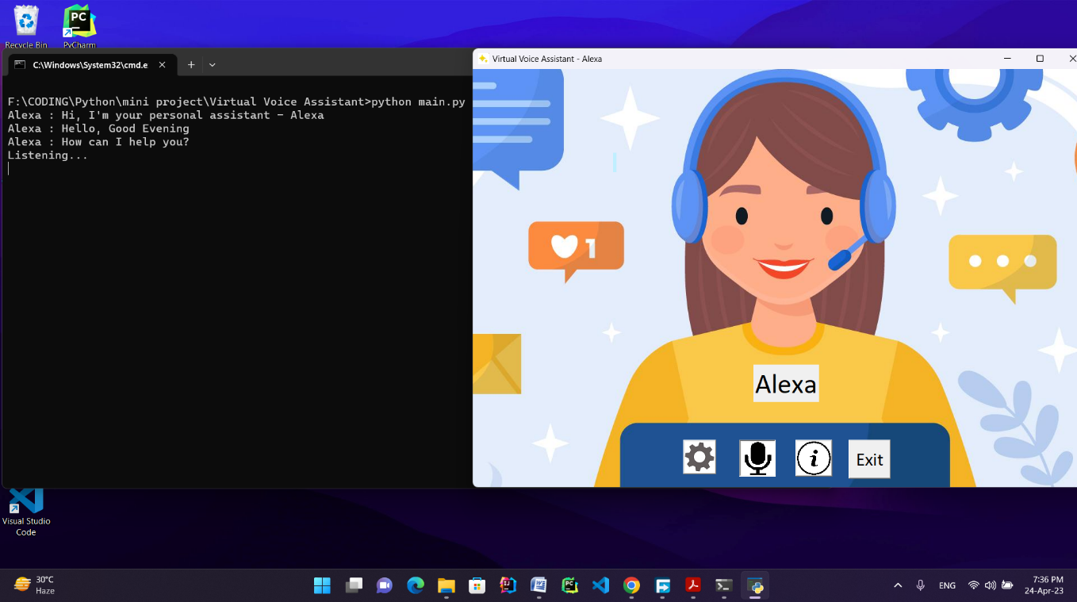

Greetings of Voice Assistant

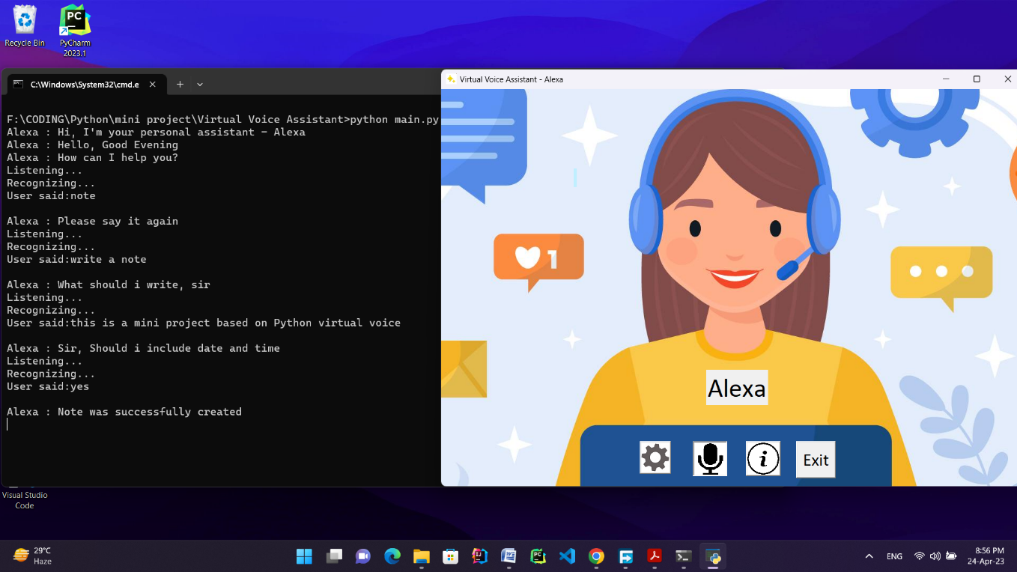

Writing a note

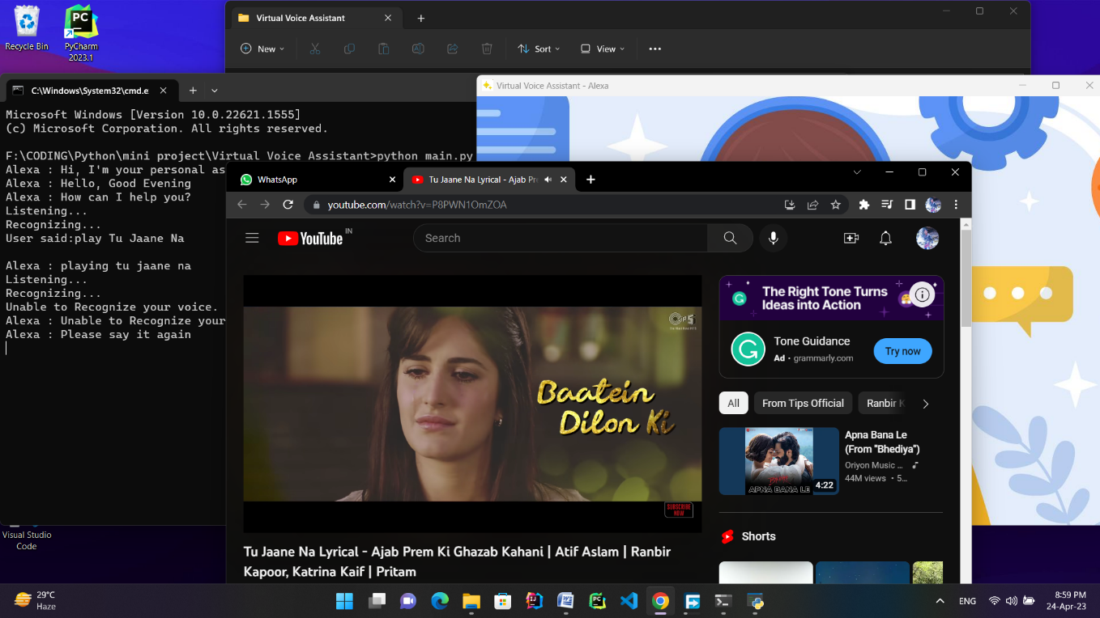

Playing music on YouTube

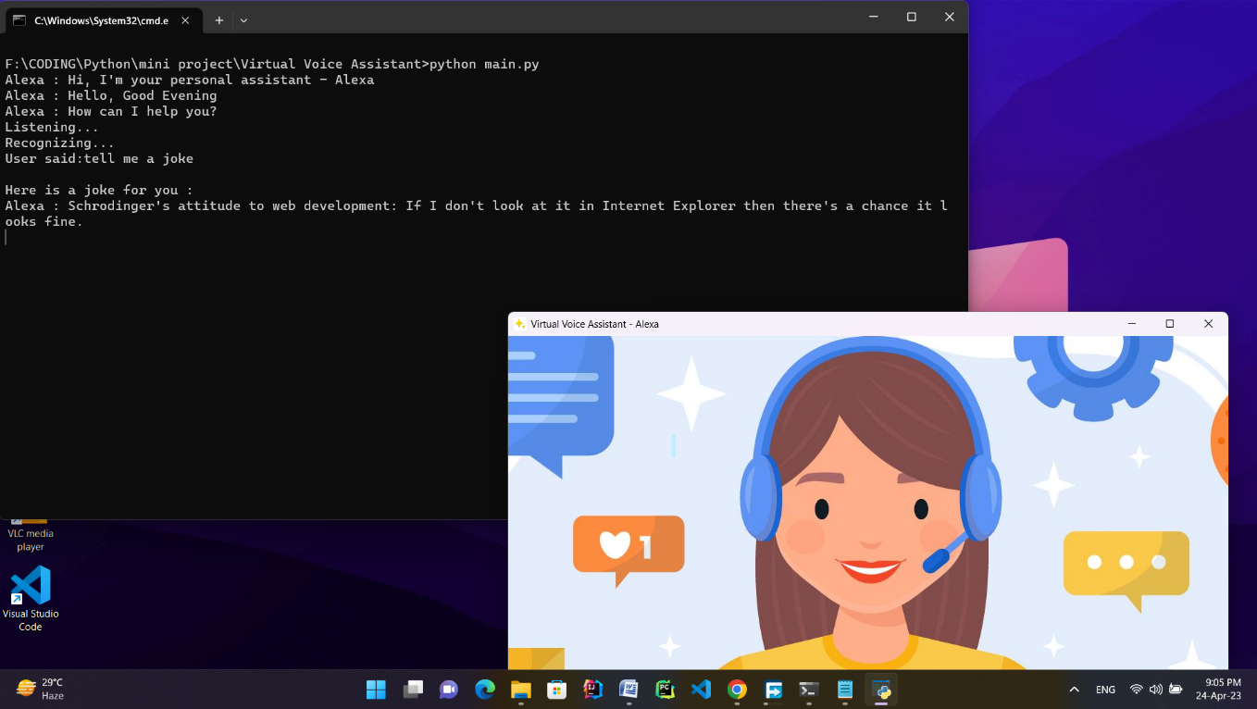

Telling a joke

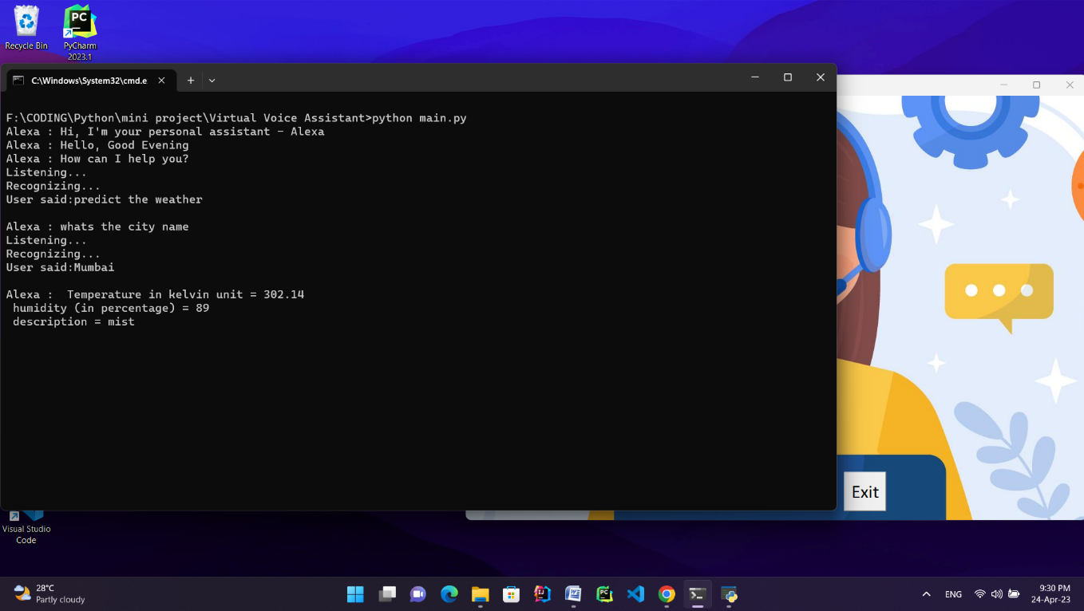

Predict the weather

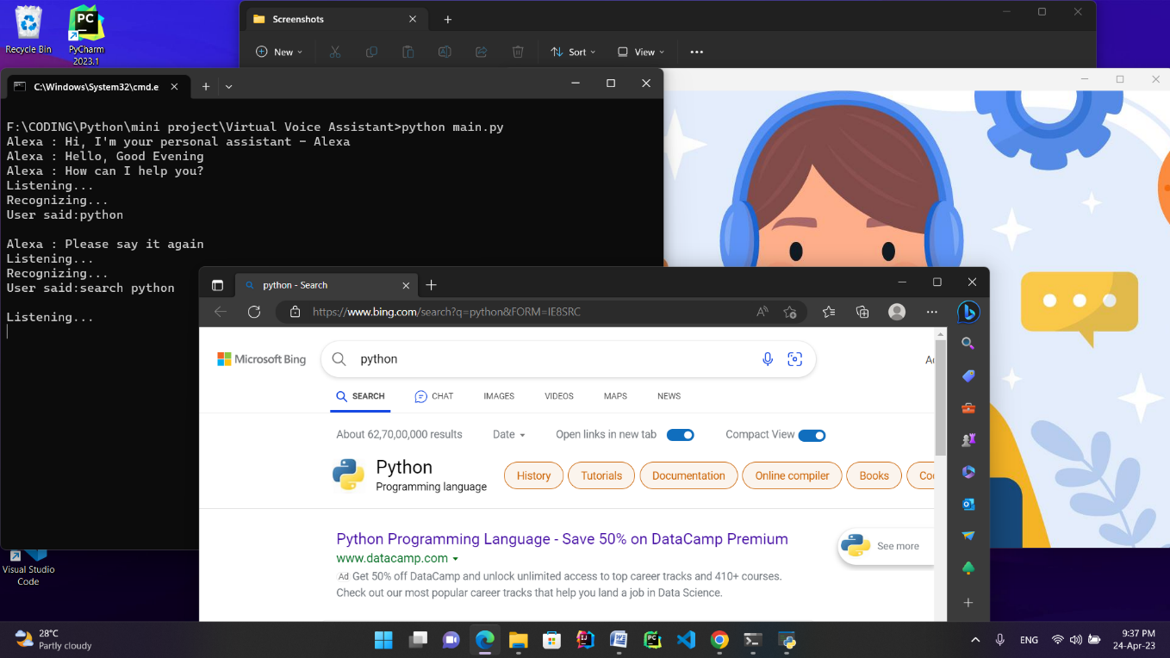

Search on web browser

**WHAT CAN VIRTUAL VOICE ASSISTANT DO?**

* Tell us the current time, news updates, jokes
* Search on google, wikipedia
* Open apps like google, youtube, gmail, chrome, stackoverflow, notepad, calculator
* Predict weather in different cities
* Play music on youtube
* Get location of a place
* Answer personal questions like: who are u, who made u, how are u, etc
* Capture a photo
* Do OS based tasks such as shutdown the pc, restart the pc, sleep, etc

**DETAILS OF SOFTWARE**

|  |  |
| --- | --- |
| Operating System | Windows 11 |
| Programming Language | Python |
| Database | MySQL |

**FUTURE ENHANCEMENTS**

Based on the survey we recommend that the application should be developed which accomplishes the desire of different users. The main reason that the user wants to use the voice assistant is to make their life easier, so by implementing the below mentioned features the user can be facilitated.

1. Developing for different languages and different accents.

2. Portability for any environment.

3. Voice authentication technology can be implemented for more security.

4. Dialogue flow needs stack with neurals

5. Deploy on web using flask or Django

6. Deploy on cloud uses amazon ec2, Heroku.

**CONCLUSION**

In this paper we have discussed about Personal Virtual Assistant For Windows Using Python. Virtual assistant makes life easier to humans. Virtual Assistant is the flexibility to contract for just the services they need. As like Alexa, Cortona, Siri, Google assistant we also make virtual assistant using python for all windows versions. We use Artificial Intelligence technology for this project. Virtual Personal Assistants are effective way to manage our daily tasks.

**REFERENCES**

* **Youtube**:- <https://youtu.be/AWvsXxDtEkU>

1.Code with Harry

2.Programming Hero

3.MacStock Tech

* **Websites**:- <https://www.geeksforgeeks.org/>

<https://www.instructables.com/>

<https://pythongeeks.org/>

<https://github.com/>

www.stackoverflow.com

www.geeksforgeeks.org

www.instructables.com

pythongeeks.org

github.com